CHAPTER 1

TITLE OF CHAPTER

There may be a preamble at the beginning of a chapter. The purpose may be to introduce the themes of the main headings.

1.1 Main heading no. 1
(Primary Level Numbering)

1.1.1 Subheading no. 1 (Secondary level numbering)

There should be at least two subheadings to justify having subheadings.

1.1.2 Subheading no. 2 (Secondary level numbering)

All first letters of principal words are capitalised and the subheading is left justified.

1.1.2.1 Tertiary heading no. 1
(Under Subheading no. 2)

There should be at least two tertiary headings to justify having tertiary headings.

1.1.2.2 Tertiary heading no. 2
(Under Subheading no. 2)

Tertiary and subsequent headings should not be listed in the Table of Contents.

Sample of Table (with vertical lines)

Table 6 (or Table 3.2) : Number of visitors according to participation in different activities

Activity | No. of participants  (N=96) | NA
Wildlife sighting Fishing Photography Camping Picnicking Visiting waterfall  Sightseeing and nature observation  Bird watching  Visiting historic sites | -  -  92 (95.8)  -  47 (49.0)  96 (100)  84 (87.5)  4( 4.2)  50 (52.1) | 96  96  4  96  49  -  12  92  46
Note: Figures in parentheses indicate percentage of N
NA: Not applicable

Sample of a Table (without vertical lines)

Table 6 (or Table 3.2) : Number of visitors according to participation in different activities

Activity | No. of participants  (N=96) | NA
Wildlife sighting Fishing Photography Camping Picnicking Visiting waterfall  Sightseeing and nature observation  Bird watching Visiting historic sites | -  -  92 (95.8)  -  47 (49.0)  96 (100)  84 (87.5)  4 (4.2)  50 (52.1) | 96  96  4  96  49  -  12  92  46
Note: Figures in parentheses indicate percentage of N
NA: Not applicable
(Source : Universiti Putra Malaysia)

Sample of Figure
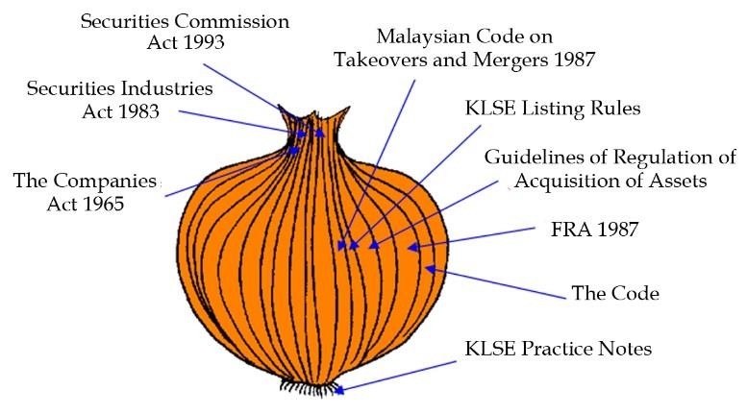
Figure 1 (or Figure 1.1) : The Corporate Governance Framework in Malaysia—The Onion Model
(Source: Hashanah Ismail, 2005)

REFERENCES

Style 1 :

Jones, B. C. (1998). Suggestions for better referencing. Journal of Business Communication, 289(3): 42-45.

Pratt, D. (1998). The Role of Religion. In M.C. McLaren (Ed.), Interpreting Cultural Differences (pp. 86-96). Norfolk: Peter Francis Publishers

Moore, W. K. (2004). Malaysia: A Pictorial History 1400-2004. Kuala Lumpur: Archipelago Press.

Style 2 :

[1] Jones, B. C. (1998). Suggestions for better referencing. Journal of Business Communication, 289(3): 42-45. (Note: In the Chapter section that should refer to references)

Notes :

The References or Bibliography section contains the list of works cited in the thesis. Students should not cite as references articles published from the studies that they themselves conducted during their candidature.

The SGS does not specify which reference style is to be used. However, students are advised to follow a style used by an authoritative journal in the field of study. Although different journals and publishers use different reference styles, a thesis has to have one (1) consistent style.

Students should check for the latest versions of different reference styles. Some systems, such as the American Psychological Association (APA) reference format, are frequently updated.

APPENDICES

Information or data that is too detailed for the main body of the thesis may be included as appendices. Appendices include original data, summary, sideline or preliminary tests, tabulations, tables that contain data of lesser importance, very lengthy quotations, supporting decisions, forms and documents, computer printouts, detailed engineering drawings and other pertinent documents. Appendix materials should be grouped by type, e.g., Appendix A: Questionnaire, Appendix B: Original data, Appendix C: Tables of results.

BIODATA OF STUDENT

This section is compulsory. It contains the student’s biographical information, such as name, educational background, the degree that is being sought, professional work experience (if any), and any other similar matters that may interest the reader. The vita should be in essay form, rather than a mere résumé.
LIST OF PUBLICATIONS

Jones, B. C. (1998). Suggestions for better referencing. Journal of Business Communication, 289(3): 42-45.

Pratt, D. (1998). The Role of Religion. In M.C. McLaren (Ed.), Interpreting Cultural Differences (pp. 86-96). Norfolk: Peter Francis Publishers

Moore, W. K. (2004). Malaysia: A Pictorial History 1400-2004. Kuala Lumpur: Archipelago Press.

Notes :

All publications (in journals and proceedings) that result from the study undertaken by the student while under supervision and during their candidature, and for which the student is the first or principal author, should be listed clearly and accurately. These publications should not be used as references in the thesis.

Students should check for the latest versions of different publications styles. Some systems, such as the American Psychological Association (APA) format, are frequently updated.

UNIVERSITI PUTRA MALAYSIA
STATUS CONFIRMATION FOR THESIS / PROJECT REPORT
AND COPYRIGHT

ACADEMIC SESSION : ________________

TITLE OF THESIS / PROJECT REPORT : _____________________________________________________________________________________________________________________________________________________________________________________________
NAME OF STUDENT :
__________________________________________________
I acknowledge that the copyright and other intellectual property in the thesis/project report belonged to Universiti Putra Malaysia and I agree to allow this thesis/project report to be placed at the library under the following terms:
1. This thesis/project report is the property of Universiti Putra Malaysia.
2. The library of Universiti Putra Malaysia has the right to make copies for educational purposes only.
3. The library of Universiti Putra Malaysia is allowed to make copies of this thesis for academic exchange.

I declare that this thesis is classified as:
*Please tick (√ )

CONFIDENTIAL (Contain confidential information under Official Secret Act 1972).

RESTRICTED (Contains restricted information as specified by the organization/institution where research was done).

OPEN ACCESS I agree that my thesis/project report to be published as hard copy or online open access.

This thesis is submitted for:
PATENT Embargo from _____________ until ____________ (date)
(date)

Approved by:

________________________ ____________________
(Signature of Student) (Signature of Chairman
New IC No/ Passport No.: of Supervisory Committee)
Name:
Date :
Date :

[Note : If the thesis is CONFIDENTIAL or RESTRICTED, please attach with the letter from the organization/institution with period and reasons for confidentially or restricted.]

